Additional file 2: Figure S1. An overview of GO function classification of differentially expressed unigenes between control and different treatments
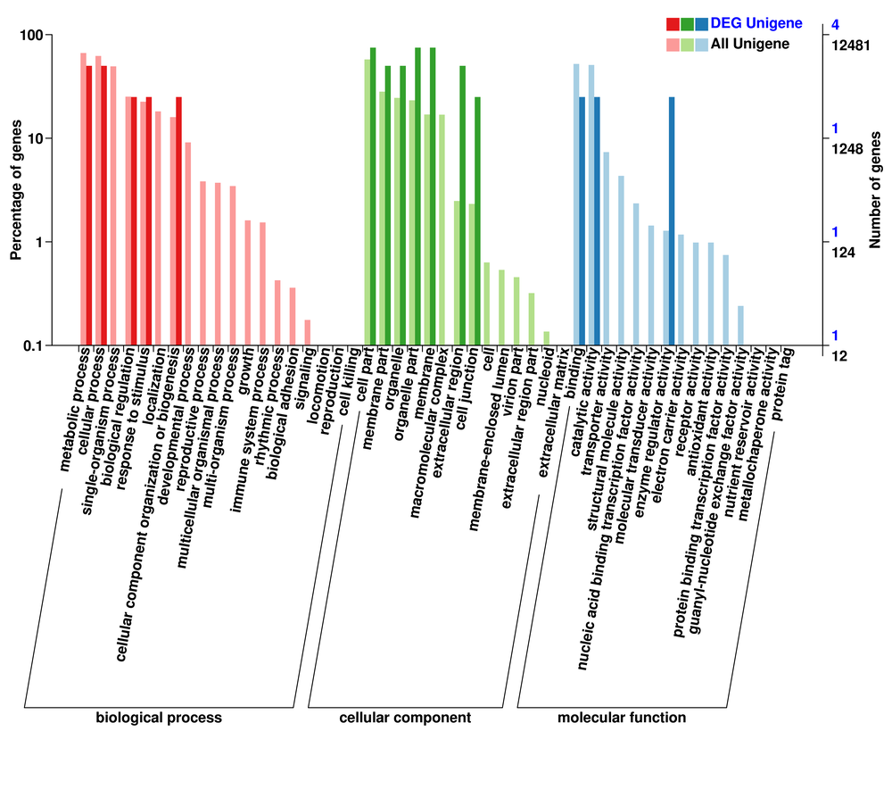
0hr vs 6 hrs - GO classification
0hr vs 1 hr GO classification
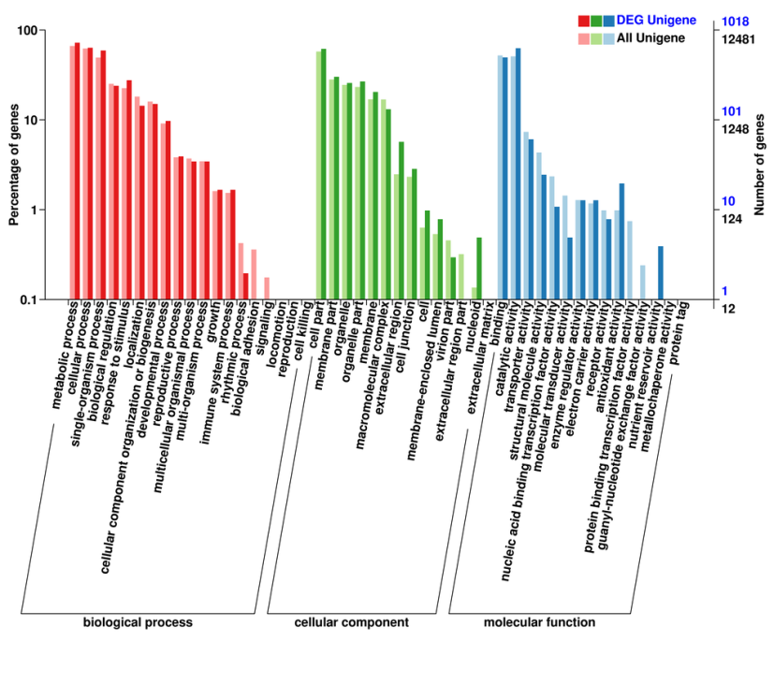
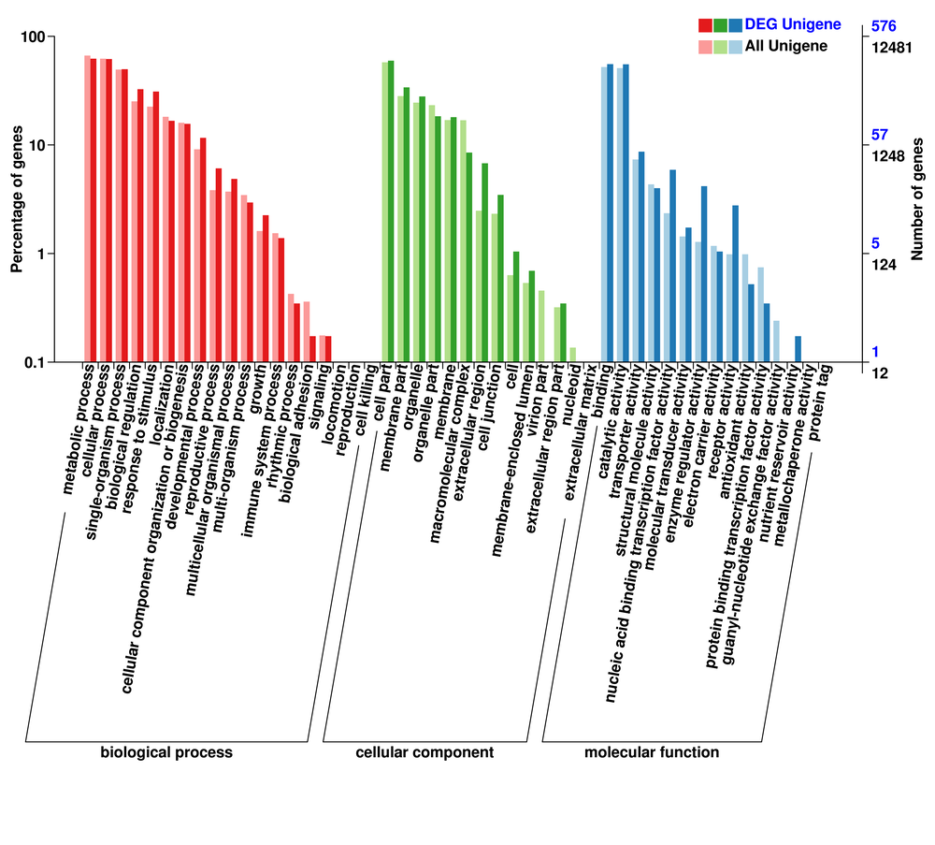
0hr vs 12 hrs - GO classification
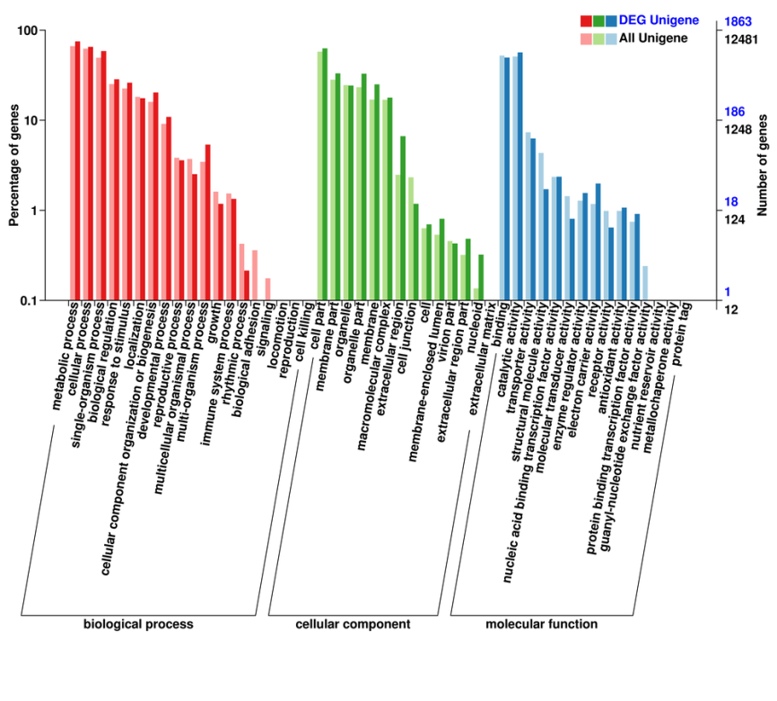
0hr vs 48 hrs - GO classification

